**TEMASEK POLYTECHNIC**

**SCHOOL OF INFORMATICS & IT**

**Software Engineering (SWEN)**

**AY2017/2018 (OCT SEMESTER)**

#### 

**Assignment 1 Submission**

**Class**: T03

**Submitted by**: <1605326F> Law Jun Wei

**Submitted by**: <1601634G> Kek Carmen

**Submitted by**: <1603304E> Gooi Chong Yen

**Submitted by**: <1600683E> Darryl Soh

**Date:** 3 / 11 / 2017

***I CERTIFY THAT THIS ASSIGNMENT IS MY OWN ORIGINAL WORK AND MATERIAL HAS NOT BEEN COPIED FROM ANY OTHER WORK (PUBLISHED OR OTHERWISE) WITHOUT ACKNOWLEDGEMENT IN THE TEXT.*** ***I AM FULLY AWARE OF THE PENALTY OF PLAGIARISM AND LATE PENALTY.***

**Name and Signature of student: ……………………………………………………**

**Name and Signature of student: ……………………………………………………**

**Name and Signature of student: ……………………………………………………**

**Name and Signature of student: ……………………………………………………**

Table of Contents

1. Group Member 1 (Law Jun Wei) 3

2. Waterfall Model 4

3. Spiral Model 5

3.1. V-Shaped Model 6

4. Group Member 2 (Kek Carmen) 6

5. Spiral Model 7

6. Big Bang Model 8

7. Iterative Model 9

8. Group Member 3 (Darryl Soh) 10

9. Waterfall Model 10

10. Spiral Model 11

11. Agile Development Model 12

12. Group Member 4 (Gooi Chong Yen) 14

13. Waterfall Model 14

14. Agile Model 15

15. Big Bang Model 16

16. Terms of Reference 18

17. Project Plan 27

# Group Member 1 (Law Jun Wei)

Software Development Life Cycle, SDLC in short, is a 5 phases process that aims to produce a high-quality software that will meet or even exceeds the customer expectations. It is used by the software industry to design, to develop and to test high quality software.

The 5 phases are:

**Requirement Engineering** – used to find out the expectation of customer of the software

**Analysis & Design** – Analysis is the understanding of business needs and processing needs. Design is the define solution system based on requirement and analysis decision.

**Implementation** – refers to detailed designs converted into instructions written in programming language.

**Testing** – a phase which the team will test out the software to ensure that it can be function and it meets the customer’s needs and requirements.

**Deployment** – refers to the application that is being distributed within a group of customers that are selected before it released.

Software development model is a plan of dividing software development work into different phases to improve the design, product and project management.

# Waterfall Model

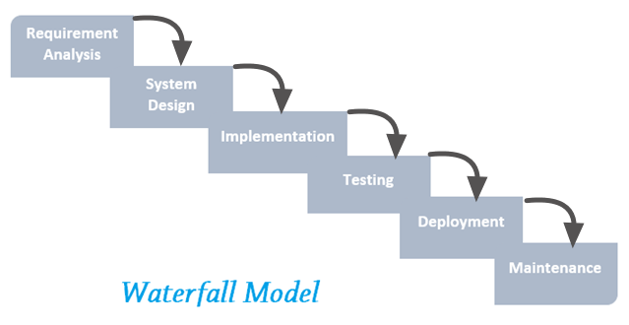

Figure 1: Waterfall Model - http://4.bp.blogspot.com/-MM6Bm5ZRYaw/V3RzO1vOeoI/AAAAAAAADzY/VEqlCc0m1i4LCz34xa23TIIgE4fO4cu_QCK4B/s1600/Waterfall%2Bmodel.png

The waterfall model is a linear sequential design process. The process is seen like a waterfall where it flows down through phases like Requirement Analysis, System Design, Implementation, Testing, Deployment and Maintenance. It is used to break down complex tasks into smaller task so that it will be manageable. It also helps to identify how each task deliver and it is easy to control and monitor because it deals with an activity at a time.

# Spiral Model

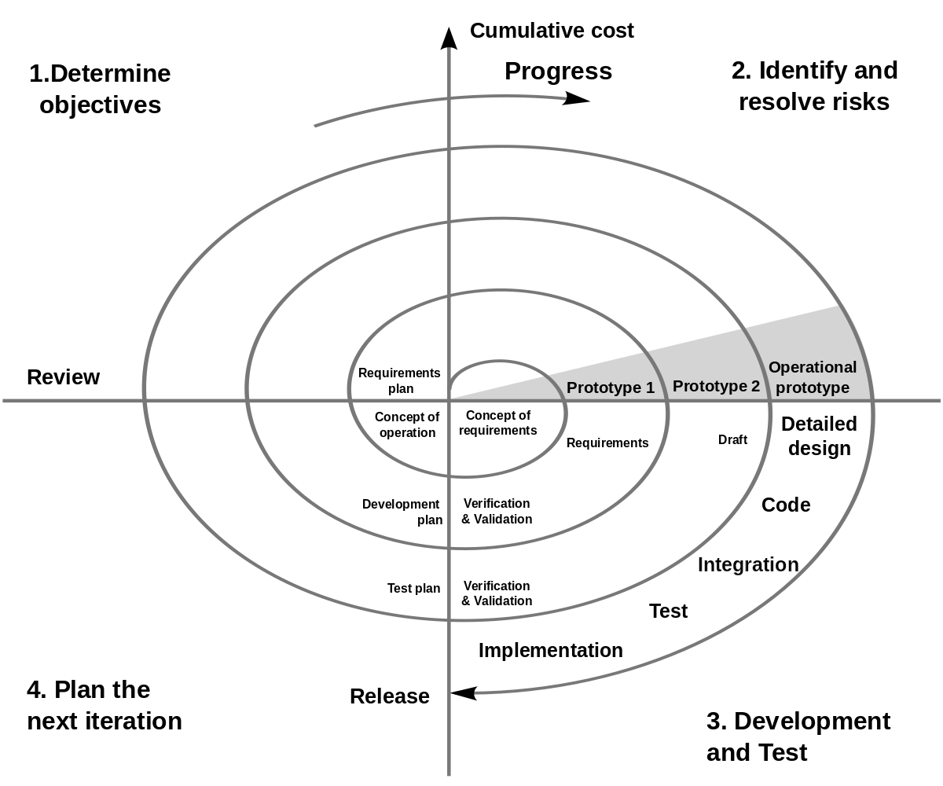

Figure 2: Spiral Model - https://upload.wikimedia.org/wikipedia/commons/thumb/e/ec/Spiral_model_%28Boehm%2C_1988%29.svg/1200px-Spiral_model_%28Boehm%2C_1988%29.svg.png

Spiral Model is one of the most adaptable SDLC method, it takes a signal from the Iterative Model and its duplication. The project will then go pass through 4 different phases over and over again in a “spiral” direction until it finished, this will allow several cycles of modification. This model allows for the building of highly custom-built product and its user feedback can be incorporated from the early stage of the project. However, the risk created will be a never-ending spiral for a project that goes on and on.

# V-Shaped Model

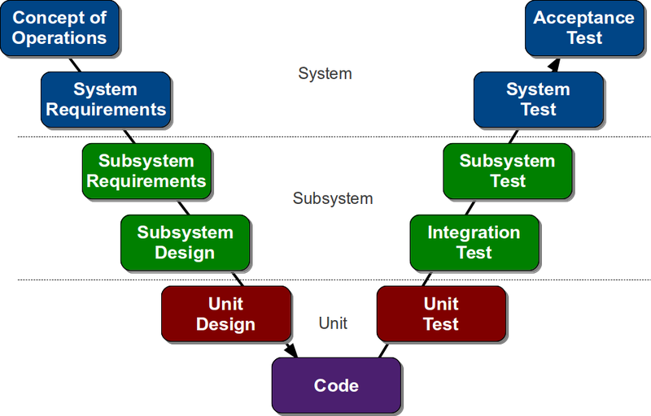

Figure 3: V-Shaped Model - https://www.automationlearn.com/s/cc_images/teaserbox_4510763.png?t=1405454106

V-Shaped Model which is also known as Verification and Validation Model, grew out of Waterfall Model and is characterised by a corresponding testing phase for each development stage. Similar to Waterfall Model, each stage starts only when the previous stage stop. It is useful when there are no unspecified requirements because its quite hard to go back and make necessary changes if there is one.

# Group Member 2 (Kek Carmen)

Software Development Life Cycle(SDLC) is a process that includes a series of detailed planned activities of how to develop, alter, maintain and replace a software system.

The phrases that are in every SLDC models are:

1. Requirement gathering and analysis
2. Design
3. Implementation or coding
4. Testing
5. Deployment
6. Maintenance

# Spiral Model

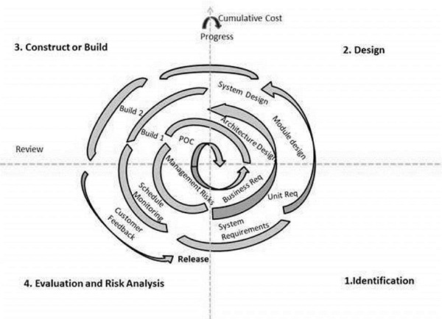

Spiral model is a risk-driven process model generator. The project’s level of effort and degree of details are all determined by the risks, so as to minimize the overall risk. It allows incremental releases of the product or incremental refinement through each iteration around the spiral. A software project implementing spiral model will repeatedly passes through its 4 phases in iterations.

In every cycle, we will allow the customer to evaluate it and provide feedback. We will then make amendments based on their feedbacks to further improve the project. The product will then be deployed in the identified market at the end of the spiral.

Spiral model is not suitable for smaller projects as it could be expensive for smaller projects that are low risk. The spiral might go on indefinitely, resulting in an unknown deadline for the project till a later date.

# Big Bang Model

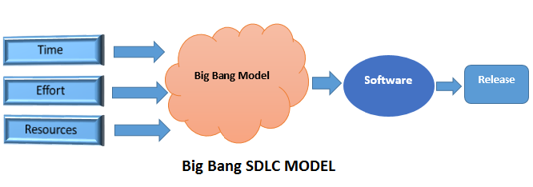

Big Bang model is ideal for small projects where the development teams are small, and customer might not be sure of what they want. It is simple and require minimal planning, making it easy to manage. The development just starts with the required money, effort and resources as the input whereas the output is the software developed which may or may not be according to the customer requirement.

However, this also results in the model being a high-risk model as misunderstanding or new changes required might end up leading to complete scraping or revamping the complete software. Thus, this model is not suitable for long, ongoing projects as well as complex projects as it could turn out to be very expensive if requirements are misunderstood, causing the project to be scraped or revamped.

# Iterative Model

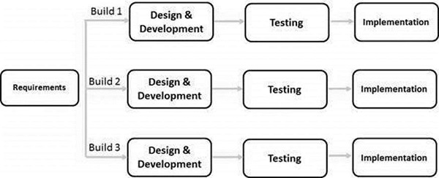

Iterative model process starts with implementation just part of a small set of software requirement instead of the full specification, and iteratively enhancing the evolving versions until the complete system is implemented and ready to be deployed. This model is ideal if requirement of the complete system is clearly defined and understood, allowing a working model of the system to be done at early stage of development which makes it easier to find functional or design flaws that needs to be amended.

The basic idea of this method is to develop a system through repeated cycles and in small portions at a time. At each iteration, design modifications are made and new functional capabilities are added. The iterative model is not suitable for smaller projects, and if customer wishes to change requirements as project proceeds.

# Group Member 3 (Darryl Soh)

The Software Development Life Cycle (SDLC) is used during the development of an IT project for software engineering and other similar application to help plan out a process for a system. The process usually consists of planning, ideation, prototype, testing and the deployment of the final system.

There are numbers of Software Development Life Cycles models that have been created and used.

The models used in this explanation will be the Waterfall Model, Spiral Model and Agile Development Model.

# Waterfall Model

The waterfall model is designed in a linear sequential approach. This means that the progress through phases moves in only one direction downwards and does not come back in a cycle, similarly to how a waterfall works. Overtime, there have been modified waterfall models that has slight variations to each phase. Winston Walker Royce’s came out with the original waterfall model.

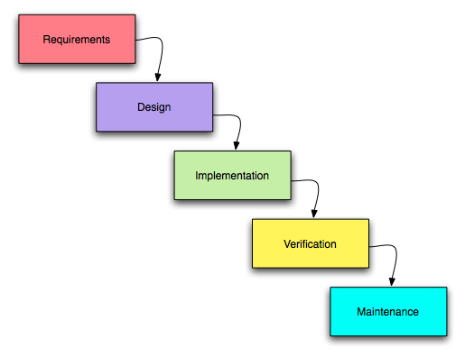

The issue with the waterfall model is that it is hard to change the design of an application once the application is deployed. This means that during the third stage of the waterfall model, the design, it has to be done properly to ensure that everything goes smoothly.

# Spiral Model

The spiral model is a designed in a cycle approach. This means that the progress through phases moves in and comes back in a cycle. The spiral model has the following phases:



Planning Phase is where the requirements are gathered and being laid out

Risk Analysis Phase is where it will identify the risks and come out with solutions that will help to solve these risks. The risks are possible conditions or events that can prevent the intended outcome of a given software.

Engineering Phase is where the development of the software is done alongside with the testing of it.

Evaluation Phase is where evaluation of the software is done, where after receiving the evaluation, it will go back to the planning phase.

The issue with the spiral model is that risk analysis is costly as it requires additional resources, hence it is not good for small project. Spiral model will also make it hard for time management, as it is more of an improvisation rather than planning.

# Agile Development Model

The agile development model is designed in an incremental and rapid cycle approach. This means that the progress through phases leads to continuous small incremental releases, with improvements being made from the previous release. Extreme Programming is one of the most well-known agile development model. This model, commonly have 5 phases, before deployment of one of the release. After the release, it will repeat the phases again and lead to the next release. The phases are similar to the waterfall cycle:

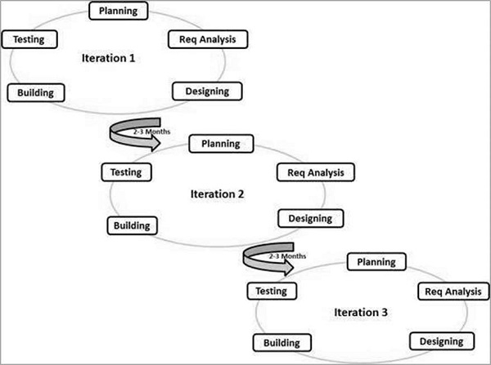

The first being to plan out the requirements of the application.

Analysis is the second stage, where the system is analyzed to see how it can be used and what the application needs.

Design is the third stage, where technical design requirements such as what programming language to be used, what services to be provided, are being covered.

Coding is the fourth stage, which is the final implementation of the application.

Testing is the fifth stage, where users, most commonly, beta testers or quality assurance, will help to discover and report issues or bugs in the application.

Operations is the final stage, where maintenance will be done to help fix the bugs and issues found in the fifth stage. This stage will determine that the application is ready for deployment.

After the 6 phases are completed. The application will be released, where it will then begin the phases again, to help improve the release from the previous one.

This model depends heavily on the customer interaction as improvements made to the releases are based on what the customer wants. Due to the many releases that have to be created with this model, documentation of the application will be lacking and passing this development to a new team will be difficult.

# Group Member 4 (Gooi Chong Yen)

The term Software Development Life Cycle or SDLC for short is a term commonly used in systems engineering and information system to describe the process of planning, creating, testing and deploying of an information system. The most common of phrases in a SDLC are planning, analysis, design and implementation.

# Waterfall Model

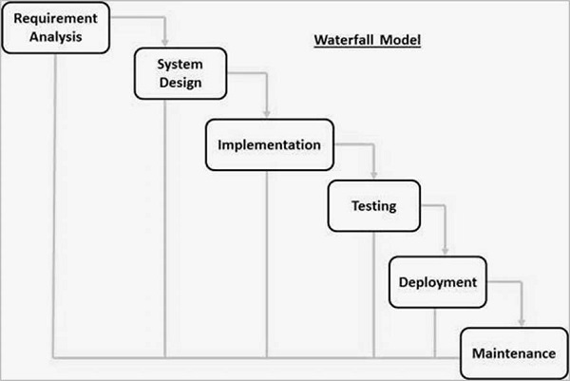

The waterfall model is the oldest and one of the most straightforward SDLC model. The model is simple. Finish one phase before moving on to the next. Each phase is highly dependent on the information from the previous phase.

However, the waterfall model is not recommended if flexibility is needed in the project as we are not able to go back to the previous phase once we move on from it. This would mean that in the event any changes are needed, they cannot be made as the model itself does not allow it.

# Agile Model

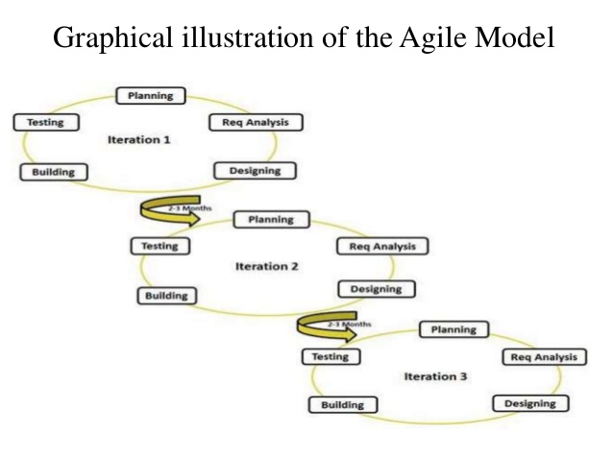

The agile model in one of the most realistic development approach. By breaking the product into different phases or cycles, this model helps to deliver a working product in the least amount of time. At each iteration, there will be small incremental changes to the product which will be tested

This model requires a lot of interaction between the customers, developers and testers. If the customer is not sure what they want, the project could go the wrong way. This would mean a lot of wasted time and money on a project that could be canceled.

# Big Bang Model

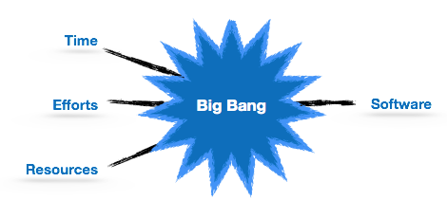

The Big Bang Model is a rather unique model compare to other SDLC models as very little time is spent on planning and majority of funds are thrown into the actual development of the product. This is one of the methods used for small projects where the client may not have a solid grasp of the requirements.

The Big Bang Model is not recommended for large and complex projects as it is a very high-risk model. In the event requirements are misunderstood in the beginning, the product might need to be completely redone.

Temasek Polytechnic

School of Informatics and IT

**Diploma in Information Technology (IT)**

Terms of Reference

**Project Particulars**

|  |  |
| --- | --- |
| Tutor | Mr Qi Yutao |
| Class | T03 |
| Project Title | Delonix Regia Hotel Management System |

**Project Team’s Particulars**

|  |  |
| --- | --- |
| Matric Number | Student Name |
| 1605326F | **Law Jun Wei** |
| 1601634G | **Kek Carmen** |
| 1603304E | **Gooi Chong Yen** |
| 1600683E | **Darryl Soh** |

# Terms of Reference

**1. Introduction**

The purpose of our project is to help the Wangs to solve their problem by coming out with a system which would help to manage their Delonix Regia Hotel. The project was assigned to our group as part of our Student Internship Programme by Pantheon Systems. The management system that we are creating will include functions that will allow hotel staffs to check on their respective working schedule, check on availability of room, booking of room as well as checking-in and out for the customer. Although the hotel is located at a good district, their business has not been up to their expectation. Hence, requesting Pantheon Systems to help them to solve their problem.

**2. Objectives of the Project**

The objective of this project is to develop a fully functional hotel management system for Delonix Regia, to help Mr. and Mrs. Wang manage the hotel more efficiently.

We propose to create a database architecture that has all the essential customers and staff's information such as customer details, online booking details, employee details, work shift schedules, room status, logistics of items.

We also propose to develop a software with the following modules:

* Booking module for the frontline desks receptionist.
* A self-check-in and check-out module for the customers
* A customer relation management module for staff.
* A maintenance management module for staff and customers.
* A room service module for customers.
* A places of interest module for customers

**3. Scope of the Project**

The system we are designing will be used to automate the major hotel operations to bring convenience to the Wangs. The following are the proposed modules and its features:

* A booking module.
  + Automate the actual booking of the rooms for customers.
  + Allow users to check the rates of the hotel as well as notifying users whenever a room is available.
  + Users will also be able to book the actual room by indicating their check-in and check-out date and time.
  + Information is updated regularly on its own without any help from staff.
* A self-check-in and check-out module.
  + Allow customers to bypass the hotel concierge and go to one of the available stations to do self-check-in or check-out.
  + Customers would only need to enter their details and the check-in and check-out process which will be handled by the computer, ensuring a smooth process for the customers.
  + The booking system will also use information from this system to update its database.
* A customer relation management module.
  + Keep track of anything that is related to the customer, such as loyalty points and membership.
  + Enable staff to check directly within the system to help customers claim their loyalty points and not need to refer to hard records which could cause mix ups
* A room service module
  + Customers will not need to call the concierge to request anything.
  + The customer only need to use the tablet provided in their room to order by first selecting the desired food, then entering the time they wish for it to be delivered to their room.
  + The tablet will then send the food order direct to the kitchen which can help prevent miscommunication between the customer and the concierge.
* A maintenance management module.
  + Service for customers to report any product or items that is spoiled or malfunctioning and needs to be replaced or maintained which they can do so via the tablet provided in the room.
  + Track rental information, schedule maintenance, items or issues that needs to be maintained
  + Contact number and details of maintenance employee for staff references
* Places of interest module
  + Accessed via the tablet provided in the room
  + It helps customers to understand popular places of interest where they can visit as well as how to get there easily
  + Module also sorts the places out via categories such as food, shopping, sceneries, etc.

**4. Distribution of Workload**

|  |  |
| --- | --- |
| Objectives/Deliverables | Members |
| Introduction, Approach and Methodology of the Project | JunWei |
| Objectives of the Project, Scope, Constraints | Carmen |
| Scope of the Project, Resources | ChongYen |
| Product Positioning in the Market/Company | Darryl |

**5. Constraints**

If Delonix Regia has their own hardware, and do not intend on purchasing a new hardware for the future usage, we will need to ensure that the software can run smoothly on the existing hardware specifications.

1. We will have limited time to create the software, thus might affect the quality of the software produced which will be based on the developers.
2. Different schedule of team members might result in lesser time to meetup together
3. Depending on the budget given to us, if the budget is not enough, the quality of the product might not be as good. We also might not be able to buy all the necessary products required.

**6. Resources**

|  |  |  |
| --- | --- | --- |
| Hardware Needed | Software Requirements | |
| 300x Tablet (Samsung Galaxy Tab S2)   * Qualcomm MSM8976 Snapdragon 652 * Octa-core (4x1.8 GHz Cortex-A72 & 4X1.4GHz Cortex-A53) * Adreno 510 * Wi-Fi 802.11 a/b/g/n/ac, dual-band, Wi-Fi Direct, hotspot. | * Android 6.0.1 * Runs the software we will be developing, mainly usage on the room service module, room maintenance management module and places of interest module. | |
| 5x Desktop (Acer Aspire C22-860 All-In-One Desktop)   * 21.5” Full HD Display * Intel Core i3-7100U processor (2.4GHz, 3MB cache) * 4GB DDR4 RAM * 1TB HDD Storage * Integrated Graphics * USB Keyboard + Mouse | * Windows 10 Pro * Runs the software we will be developing, mainly the booking module, customer relation management module and room maintenance management module. | |
| 5x Kiosk   * Touch-enabled 22” LCD LED Backlit display * LAN and WAN enabled * 256GB HDD * 4GB RAM | * Windows 10 Pro * Runs the software we will be developing, mainly self-check-in and check-out module. |
| 1x Server Desktop (Dell PowerEdge T330 Server)   * Intel Xeon E3-1220 v5 3.0GHz, 8M cache, 4C/4T, turbo (80W) * 1TB HDD * 8GB ECC RAM * On-Board LOM 1GBE Dual Port | * Windows Server 2016 * SQL Server 2016 * IIS 10 |

**7. Product Positioning in the Market/Company**

Our product has a few distinct modules: Booking, self-check-in and check-out, room service, customer relation management, maintenance management and places of interest. Unlike most traditional as well as modern day hotels, the development of a fully functional hotel management system will put Delonix Regia a step ahead among many other companies and hotels. In each of these modules, we have features that will make us stand out among the many different hotel management system.

* In many hotels, customers approach the front receptionist and communicate with them while the front receptionist does the booking process manually. Sometimes, miscommunication can occur and may lead to mistakes in the booking process. The players also do not have much freedom in choosing what they want as the front receptionist will usually be the one recommending which room the customer should get. The booking module aims to help the front receptionist automate the actual booking of the rooms for customers. It will allow users to check the rates of the hotel directly from the product as well as notifying users whenever a room is available without the need of asking the staff. Users will also be able to book the actual room by indicating their check-in and check-out time. All this information is updated regularly on its own without any help from staff. The rooms displayed in this module are also sorted by the most recommended for the user based on their budget, check-in and check-out time, as well as amount of people staying. This will help make the booking process for the customer much more convenient, reliable and faster, while not giving the front receptionist much to worry about.
* In many hotels, the receptionist counter usually has a queue as they serve to do the check-in and check-out process alongside with the booking process. This may lead to longer waiting time as the customers have to wait just to check in or check out. The check-in and check-out module will allow customers to simply use the kiosk available to check-in or check-out from their rooms. Customers would only need to enter their details and the check-in and check-out process will be handled by the computer. This will ensure a smooth process for the customer. The booking system will also use information from this system to update its database. The booking system will automatically deliver information to the booking module regarding the room availability once a user check-in or check-out in this module, automating the process where as compared to most hotels, the hotel receptionist has to manually change and update the room availability in the database.
* In most hotels, customers call the concierge to request for room service. This can sometime lead to miscommunication between the customer and the concierge. The room service module ensures that unlike most hotels, customer will not need to call the concierge to request anything. The customer need only use the tablet provided to order their food. The tablet will then send the food order direct to the kitchen. The customer will also be able to view their order before placing it and prevent accidental mistakes made in orders.
* In most hotels, calling the concierge allow the customers to request a variety of things, such as room service, hotel room enquiry and malfunction of items. This will only cause the concierge to have more tasks to handle. Hence the maintenance management module allows customer to report any product or items that needs to be replaced or maintained through the tablet. This module also provides contact details of maintenance employee for customer to directly contact them.
* In some hotels, they provide brochures that shows tourists popular places of interest in that area. For us, alongside with brochure that customers can bring out, customers can use the tablet in their hotel room for an interactive display of information regarding the various popular places of interest in the country.

**8. Approach and Methodology of the Project**



Figure 5： Agile Model - https://www.tutorialspoint.com/sdlc/sdlc_agile_model.htm

1. The first being to plan out the requirements of the application.
2. Analysis is the second stage, where we will analyze the requirements to make the product more fitting.
3. Design is the third stage, where technical design requirements such as what programming language to be used, what services to be provided, are being covered.
4. Building is the fourth stage, which is the final implementation of the application.
5. Testing is the fifth stage, we will release the software where users, most commonly, beta testers or quality assurance, will help to discover and report issues or bugs in the application. This stage is where we will gain feedback.
6. After getting the feedback needed, we will then repeat the steps for the next iteration.

We choose Agile Method, where it will break the project into several segments for different functions. This will help our team to focus on one function at a time and present it to customer to gather more feedbacks from them to better develop it. This also allows our team to make necessary changes more easily.

However, there are also disadvantages of using this model. This model depends heavily on customer interaction, so if the customer is not clear about their requirement, it may cause the whole team to go on a wrong direction. Lack of documentation, maybe quite challenging for transferring of technology to new team members.

This model depends heavily on the user's interaction as improvements made to the releases are based on what the user wants. Due to the many releases that have to be created with this model, documentation of the application will be lacking and passing this development to a new team will be difficult.

However, with great feedback given by feedback, this model will be highly useful. Due to the high usage of the software, we will be ensured that many feedback will be given, hence making this model great as we can make many continuous small incremental releases that are improvements to the previous.

Table of Contents

Contents

1 Introduction 27

1.1 Objectives and scope of the project 27

1.2 Assumptions and constraints 28

1.3 Definitions and acronyms 29

2 Roles and responsibilities 30

3 Estimates and project schedule 31

3.1 Work breakdown structure 31

3.2 Project Schedule 34

3.3 Budget Summary 34

4 Risk Management Plan 35

# Project Plan

1 Introduction

1.1 Objectives and scope of the project

The objective of this project is to develop a fully functional hotel management system for Delonix Regia, to help Mr. and Mrs. Wang manage the hotel more efficiently.

We will create a database architecture with the use of SQL Server that has all the essential customers and staff's information such as customer details, online booking details, employee details, work shift schedules, room status, logistics of items.

We will develop a software which will interact with our database with the following modules:

* Booking module.
  + Automate the actual booking of the rooms for customers.
  + Allow users to check the rates of the hotel as well as notifying users whenever a room is available.
  + Users will also be able to book the actual room by indicating their check-in and check-out date and time.
  + Information is updated regularly on its own without any help from staff.
* Self-check-in and check-out module.
  + Allow customers to bypass the hotel concierge and go to one of the available stations to do self-check-in or check-out.
  + Customers would only need to enter their details and the check-in and check-out process which will be handled by the computer, ensuring a smooth process for the customers.
  + The booking system will also use the information from this system to update its database.
* Customer relation management module.
  + Keep track of anything that is related to the customer, such as loyalty points and membership.
  + Enable staff to check directly within the system to help customers claim their loyalty points and not need to refer to hard records which could cause mix ups
* Room service module
  + Customers will not need to call the concierge to request anything.
  + The customer only need to use the tablet provided in their room to order by first selecting the desired food, then entering the time they wish for it to be delivered to their room.
  + The tablet will then send the food order direct to the kitchen which can help prevent miscommunication between the customer and the concierge.
* Maintenance management module.
  + Service for customers to report any product or items that is spoiled or malfunctioning and needs to be replaced or maintained which they can do so via the tablet provided in the room.
  + Track rental information, schedule maintenance, items or issues that needs to be maintained
  + Contact number and details of maintenance employee for staff references
* Places of interest module
  + Accessed via the tablet provided in the room
  + It helps customers to understand popular places of interest where they can visit as well as how to get there easily
  + Module also sorts the places out via categories such as food, shopping, sceneries, etc.

1.2 Assumptions and constraints

Assumptions:

1. We assumed that Delonix Regia has 300 rooms
2. Delonix Regia do not have any of the required pc, tablets and server computers.
3. The personal computers bought comes with Windows 10 home, and should be upgraded to Windows 10 Pro
4. The tablets bought comes with android 6.0.1 installed
5. Server desktops comes with Windows Server 2016 and everything is set up
6. Kiosk does not come with the OS installed, and has to be bought and installed [Self-check-in and out module]
7. Tablets will be using the hotel Wi-Fi.
8. Server desktops, desktops and kiosk will be using LAN for connectivity.
9. Server desktops will be used to host web services (web sites, etc) as well as host databases with all customer information in it.
10. Delonix Regia has facilities such as gym, spas and bar so that customers can pay for these additional services [Booking Module]
11. Assume that the software engineers already have the required software needed to develop the product.

Constraints –

1. We have to ensure the software can run smoothly on the hotel’s existing hardware specifications.
2. Budget wise, if there are not enough budget we might not be able to buy all the required products

1.3 Definitions and acronyms

|  |  |
| --- | --- |
| Definition | Acronyms |
| Software Development Life Cycle (Used to plan out how to develop the software) | SDLC |
| Structured Query Language (Used for the hosting and management of database) | SQL |
| Internet Information Services (Used for the hosting of web services) | IIS |
| Operating System | OS |
| Local Area Network (Used to connect to the internet via cable) | LAN |

2 Roles and responsibilities

|  |  |
| --- | --- |
| **Objectives/Deliverables** | **Members** |
| Booking module | JunWei |
| Check-in and Check-out module | JunWei |
| Customer Relation Management module | Carmen |
| Room Service module | Carmen |
| Maintenance Management module | ChongYen |
| Places of Interest module | ChongYen |

3 Estimates and project schedule

3.1 Work breakdown structure

Booking module

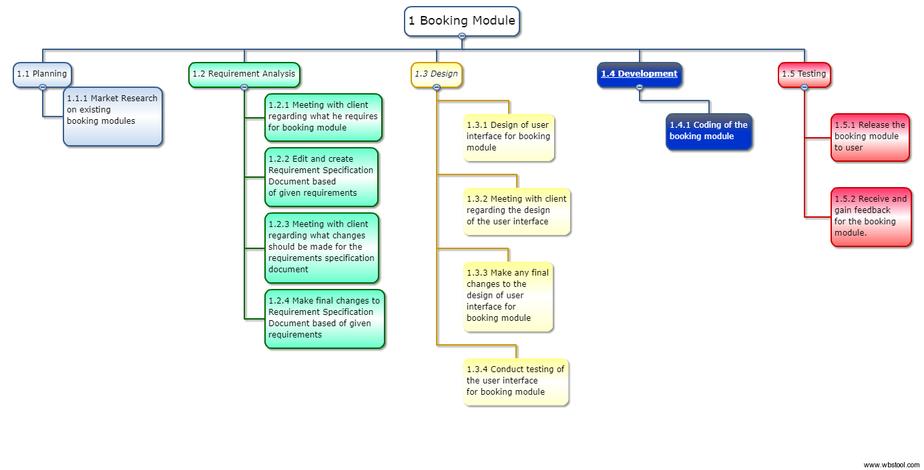

Self-check-in and Check-out module

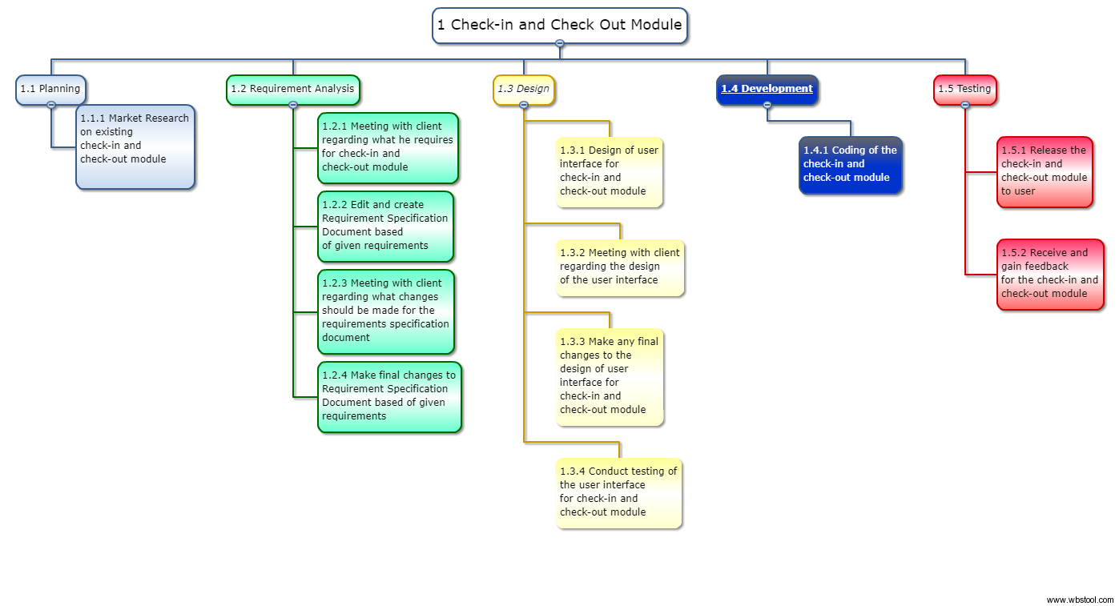

Customer Relation Management module

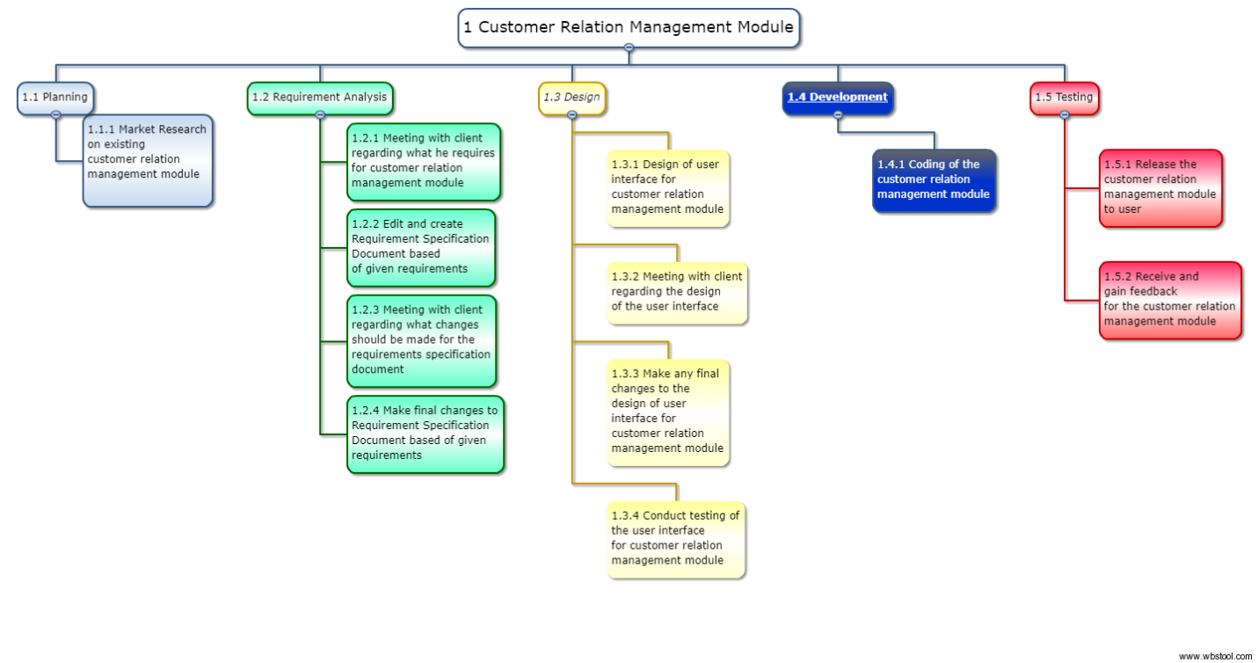

Room Service module

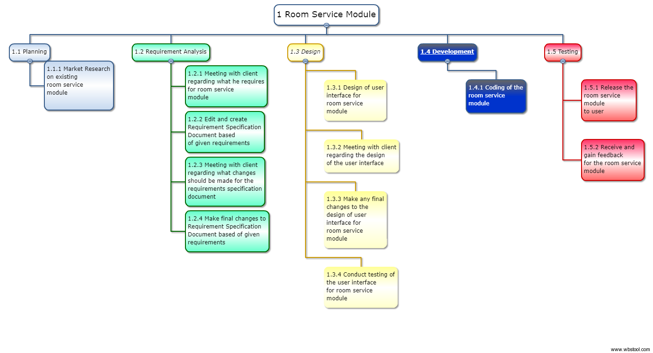

Maintenance Management module

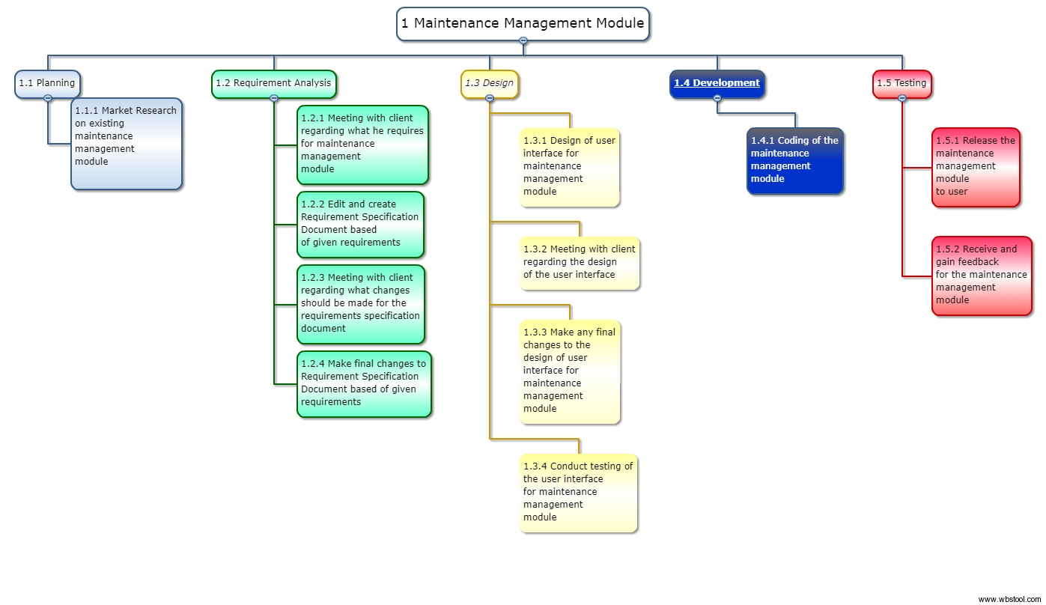

Places of Interest module

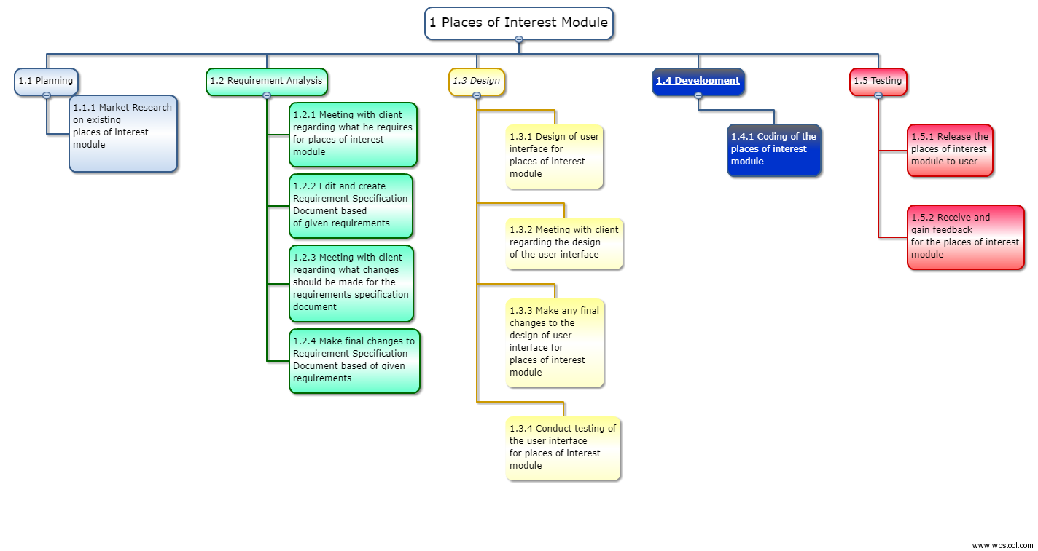

3.2 Project Schedule

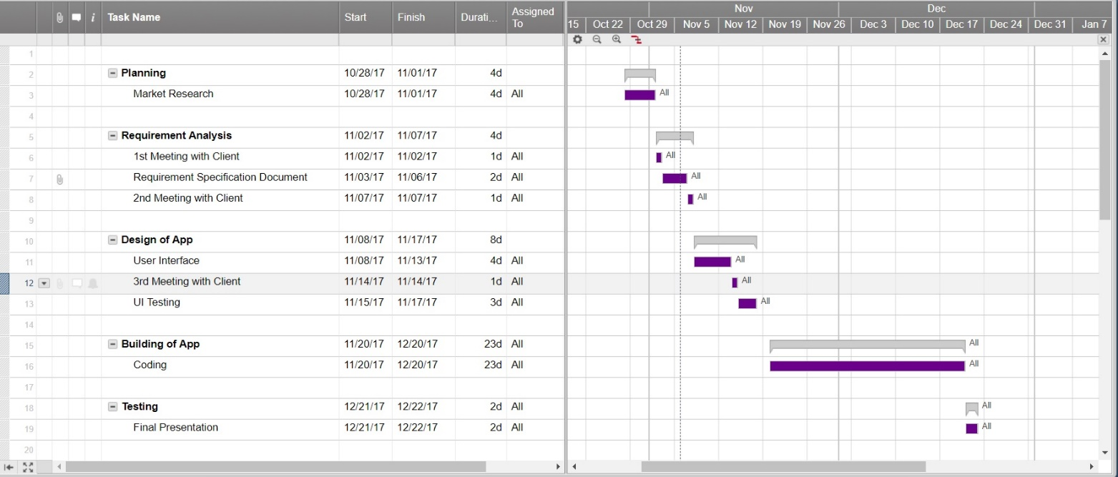

3.3 Budget Summary

|  |  |  |
| --- | --- | --- |
| Category | Item | Amount (S$) |
| Hardware | 300x tablets  1x Server Desktop  5x Kiosk machine  5x Desktop | (300 x $400) +  (1 x $4,000) +  (5 x $4,000) =  $144,000 |
| Software | 10x Windows 10  1x Windows Server 2016 Standard | (5 x $400) +  (1 x $2,000) =  $4,000 |
| Manpower | 1x Software Engineer for half a year of project development | $51,080 |
| Total |  | $199,080 |

4 Risk Management Plan

|  |  |  |  |
| --- | --- | --- | --- |
| **Type of Risk** | **Severity of impact** | **Likelihood of occurrence** | **Risk Exposure** |
| Unclear Project Specifications | High (3) | High (3) | 9 |
| Incorrectly Planned Project Schedule | High (3) | Medium (2) | 6 |
| Delays in Stakeholder Approval | Low (1) | Low (1) | 1 |
| Insufficient Personnel | High (3) | High (3) | 9 |
| Lack of Resources | Medium (2) | Medium (2) | 4 |
| Change of Business Strategy | Medium (2) | Medium (2) | 4 |
| Change of Target Audience | High (3) | Low (1) | 3 |
| Funding Cuts | Medium (2) | Low (1) | 2 |
| Delays in Financial Approval | High (3) | High (3) | 9 |
| Natural Disaster | High (3) | Low (1) | 3 |